How To Create And Build Docker File

1.Create a Dockerfolder and create Docker file

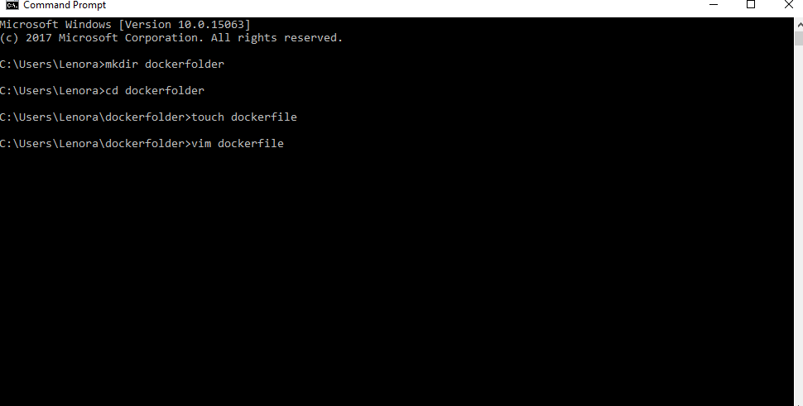

2.Type following commands

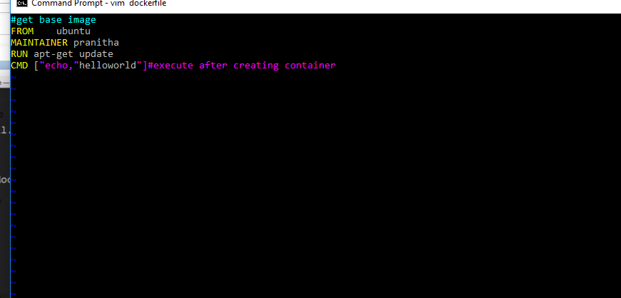

3.Open dockerfile

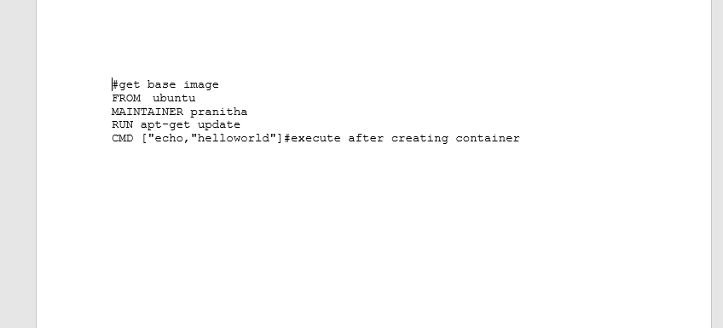

4.Build image by running docker build -t <imagename>

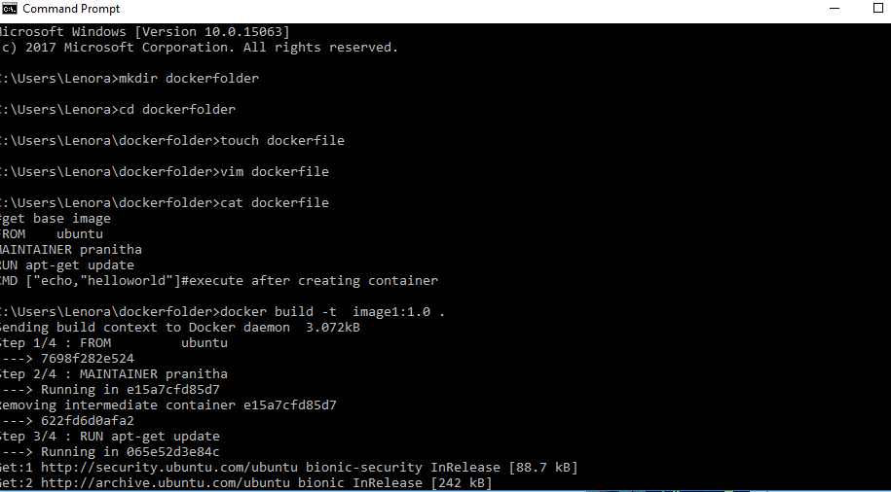

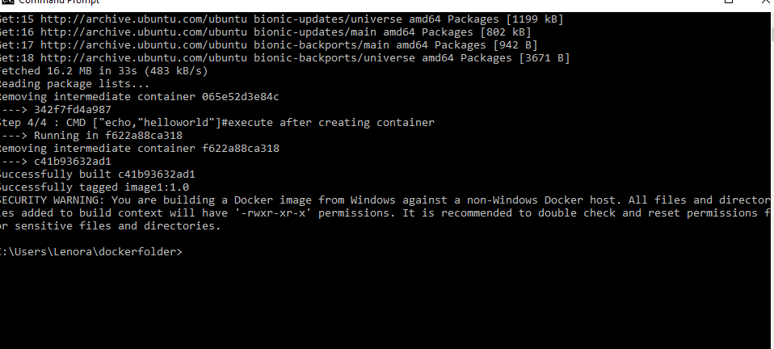

5.Type dockerimages and use docker run <imagename> to create container

